
Name : Vinishraj R
Roll no : 240701591
Experiment No. 1: Comparative Study
of Low-Code Development Versus
Traditional Application Development
Approaches
1.
Aim
To study and compare the Traditional Application Development approach with
the Low-Code Development approach based on their development process,
speed, cost, flexibility, and ease of use.
2.
Introduction to Traditional Application Development
Traditional application development is the conventional method of building
software by writing source code using programming languages such as Java,
Python, C#, or
JavaScript. Developers manually design, code, test, deploy, and maintain the
application.
This approach provides complete control over the application's functionality,
performance, and customization. However, it requires skilled developers, longer
development time, and higher development costs.
Features
● Manual coding is required.
● High flexibility and customization.
● Suitable for complex applications.
● Requires experienced developers.
● Longer testing and deployment cycles.
3.
Introduction to Low-Code Development
Low-code development is a modern software development approach that enables
applications to be built using graphical user interfaces, drag-and-drop
components, and minimal hand-written code.
It allows both professional developers and non-technical users (citizen developers)
to create applications quickly, reducing development time and effort.

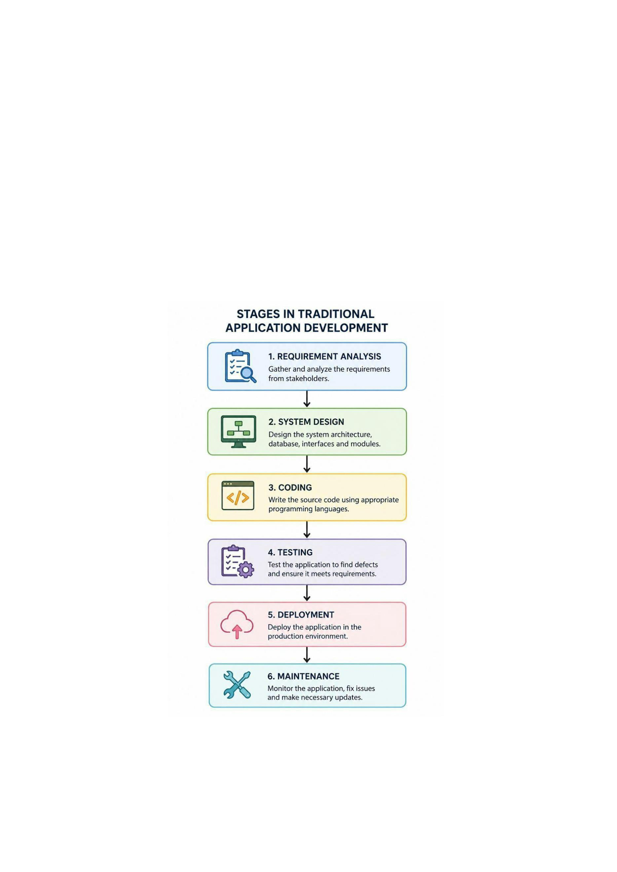
Examples of low-code platforms include Microsoft Power Apps, Mendix,
OutSystems, and Appian.
Features
● Drag-and-drop interface.
● Minimal coding required.
● Faster application development.
● Easy integration with existing systems.
● Suitable for rapid application development and business applications.
4.
Diagram for Stages in Traditional Application Development

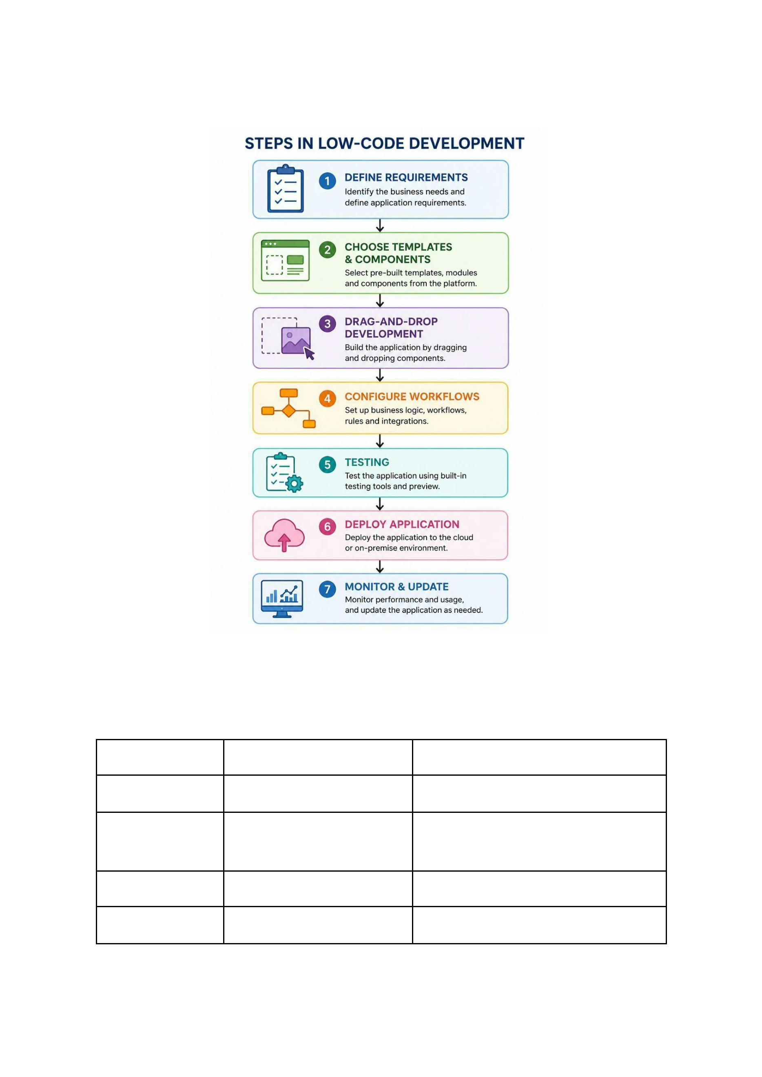
5.
Diagram for Steps in Low-Code Development
6.
Comparative Analysis of Traditional and Low-Code
Development
Parameter
Traditional Development Low-Code Development
Coding
Extensive manual coding Minimal coding
Development
Speed
Slow
Very Fast
Low
Development Cost High
Required Skills
Professional programmers Developers and non-developers


Customization
Very High
Moderate to High
Parameter
Learning Curve
Maintenance
Testing
Traditional Development Low-Code Development
Steep
Easy
Time-consuming
Mostly manual
Takes more time
Easier
Automated tools available
Quick deployment
Deployment
Large and complex
applications
Business applications and
rapid development
Best Suitable For
7.
Result
The comparative study shows that Traditional Application Development offers
maximum flexibility and customization but requires more time, skilled developers,
and higher costs.
On the other hand, Low-Code Development significantly reduces development
time, simplifies application creation, and lowers development costs, making it
ideal for rapid application development and business solutions. The choice
between the two approaches depends on the project's complexity, budget, and
development timeline.

